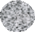
ScienCel TM

Research Laboratories

Certificate of Analysis

Product Name Rat Astrocytes - adult (RA-a)
Catalog Number R1860
Lot Number 17277
CA Number 0002972

TEST General: Morphology Cell number | SPECIFICATION  Astrocyte  ≥ 5 x 105 | RESULTS  Pass  9.40 x 105
Viability | ≥ 70% | 85.1%
Proliferative potential | ≥ 5 pd | Pass
Phenotype Characterization:
GFAP | Positive | Pass
Potential Biological Contaminants:
HIV-1 DNA | Not detected | Pass
HBV DNA | Not detected | Pass
HCV DNA | Not detected | Pass
Mycoplasma DNA | Not detected | Pass
Bacteria / Fungi | Negative | Pass

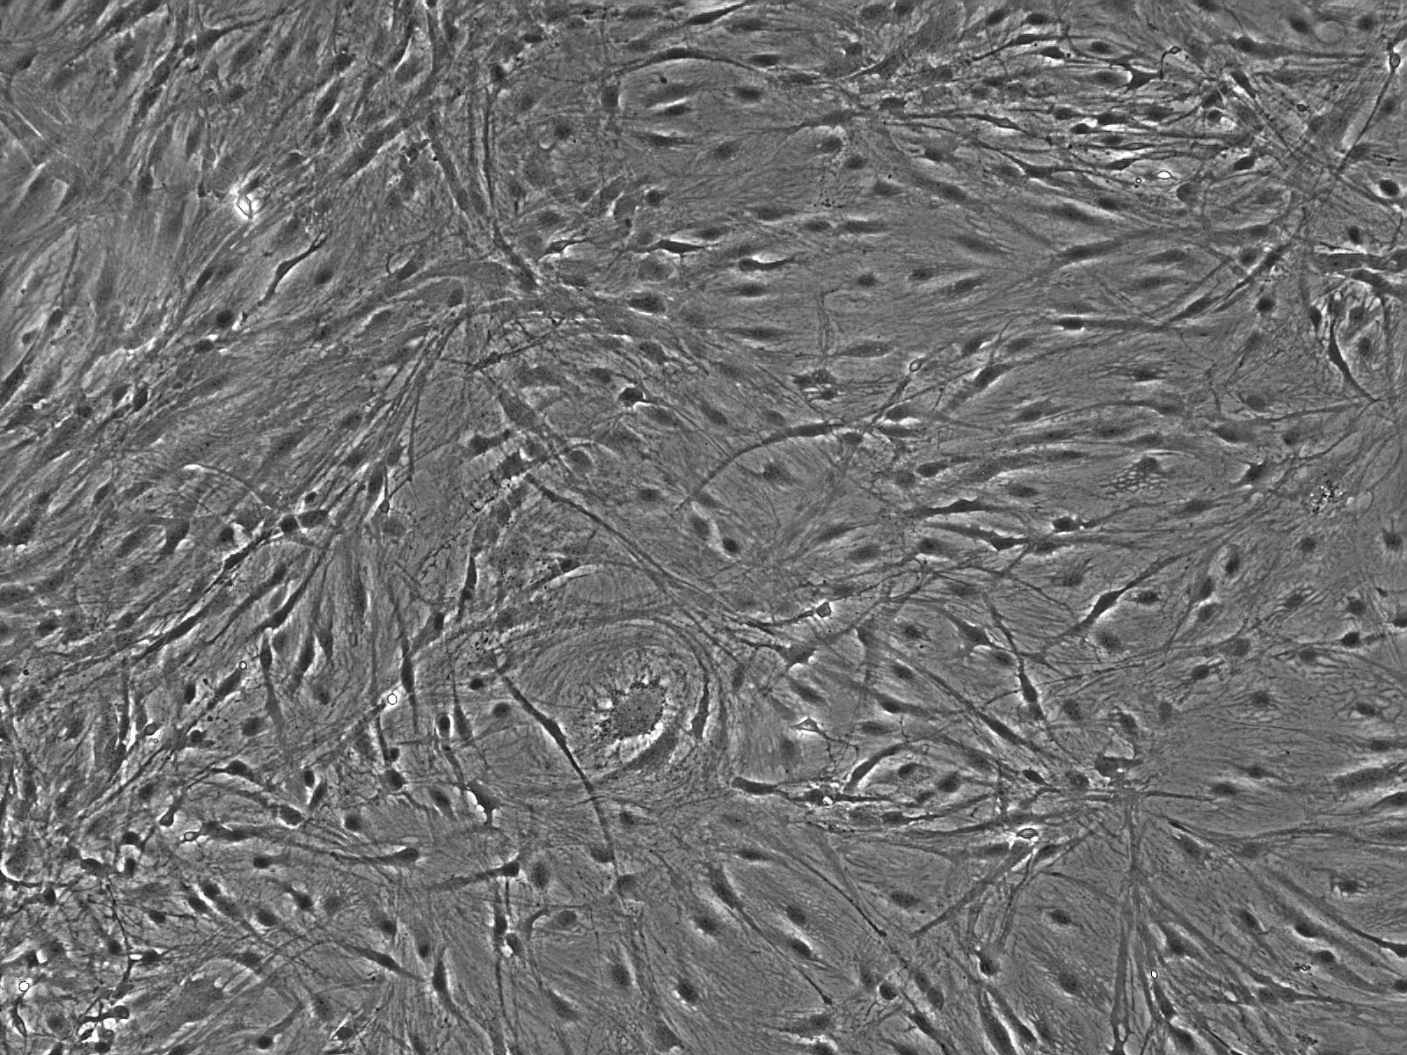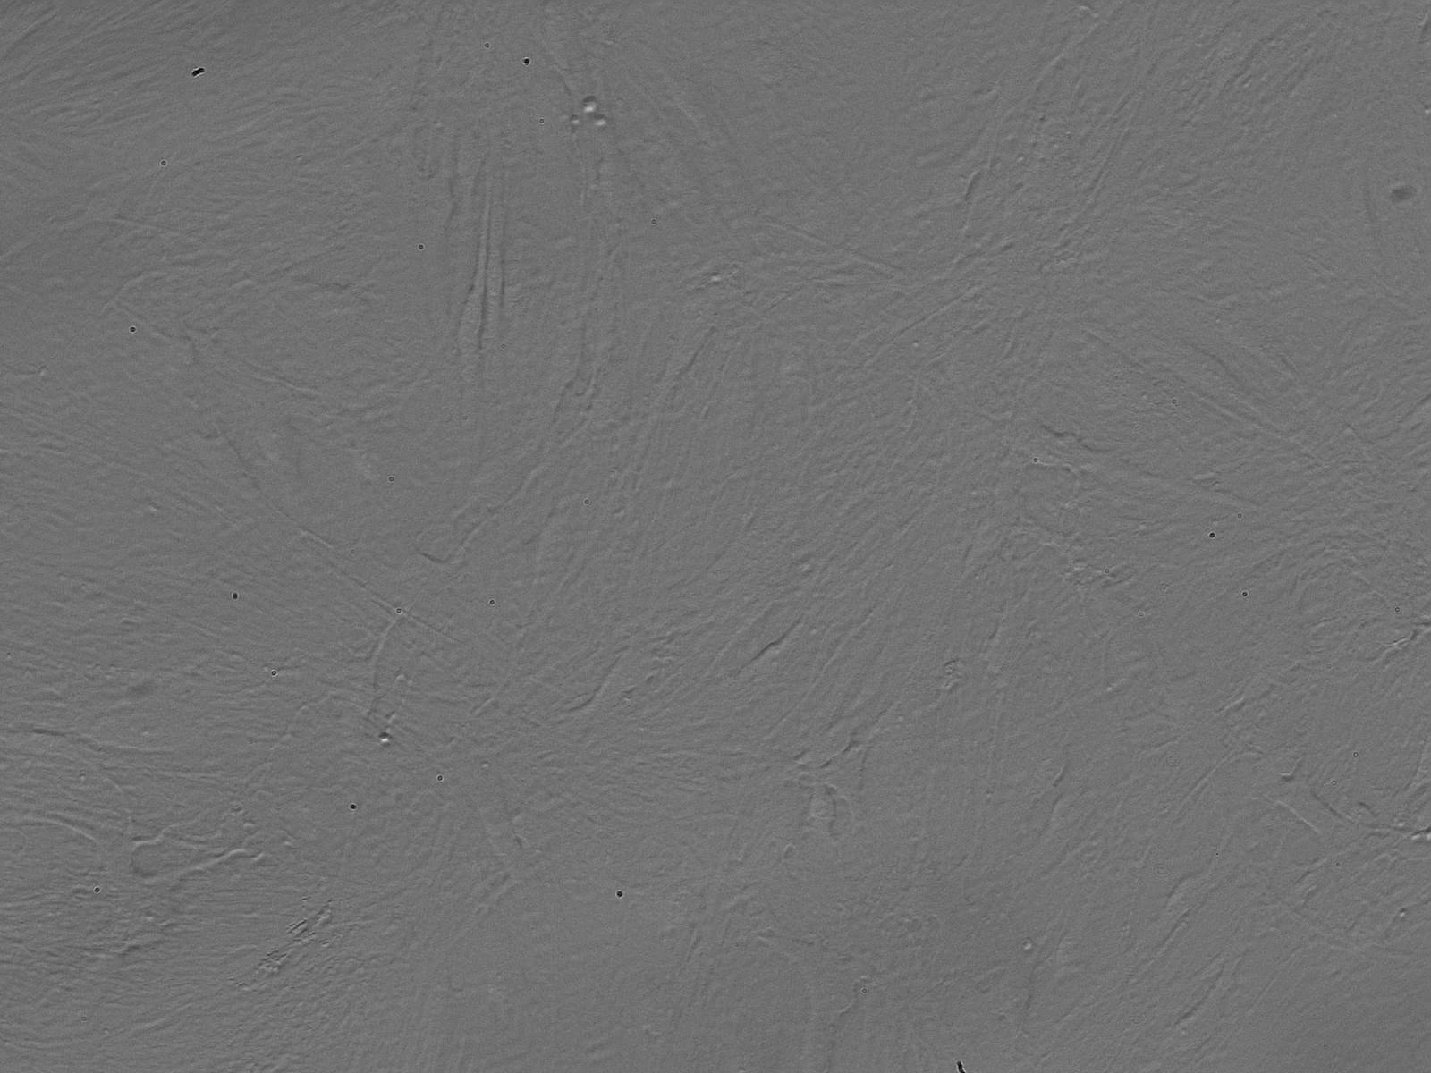
Fig.2 Relief Contrast Morphology of cultured RA-a at P0.20X.
Fig.1 Phase Contrast Morphology of cultured RA-a at P0. 10X.

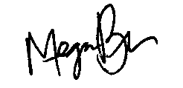
Approved on 09/25/2015

Megan Burrow
Quality Control

ScienCell Research Laboratories www.sciencellonline.com info@sciencellonline.com
Tel. 760-602-8549; Fax. 760-602-8575
Copyright©2001 ScienCell Research Laboratories

